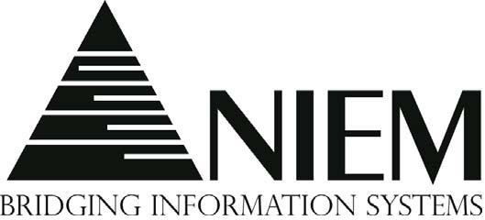

NIEM Domain Guidebook
April 2011

- Table of Contents
1. Introduction 4
1.1 Background and Purpose 4
1.2 How to use the Guidebook 4
1.3 Definition of Key Terms 4
1.4 Document Organization 4
1.5 Communications Approach 5
2 Administrative 6
2.1 Domain Governance 6
2.2 Domain Communication 7
2.3 NIEM Configuration Control Tool (NCCT) Issue Processing 9
2.4 Maintain the Domain 11
3 Data Management 14
3.1 Domain Readiness Assessment 14
3.2 Identify and Define Data 18
3.3 Publish / Release a NIEM Domain or Content 21
3.4 Security and Privacy 25
4 Interoperability 30
4.1 Cross-domain Harmonization 30
4.2 Core Synchronization 30
4.3 Domain Reconciliation 30
Appendix A – Community of Interest 31
Appendix B – Considerations for NCCT issues and associated data modeling 36
Appendix C – Domain Charter Template 39

Introduction

Background and Purpose
In recent years, the National Information Exchange Model (NIEM) has experienced governance challenges as the NIEM community grows and establishes new domains and existing domains mature. This has led to the need for documentation to provide the NIEM community with a baseline understanding of common NIEM guidance and processes. The subsequent sections provide the following: how to use the Guidebook, definition of key terms, an overview of the information contained within each section, and detailed information about how to correctly execute each process. This document is written for NIEM stakeholders with business architecture knowledge. Therefore, it does not include detailed technical information. For technical information, refer to the NIEM Baseline Specification on NIEM.gov.

How to use the Guidebook
This guidebook is based on feedback and questions received by the NIEM PMO. It should be referenced by the domain community to help support domain operations. Domains can use the entire Guidebook or just relevant sections.

Definition of Key Terms
Term | Definition
Domain committee support staff | The individual responsible for working with the Domain POC to manage the activity of the domain. This role may be filled initially by the NIEM PMO, however on-going support will need to be provided by the organization of the Domain Steward(s)
Domain member | A subject matter expert in the topic area of the domain. The domain should adequately represent the community of interest with both Federal government and state & local members
Domain primary points-of-contact | The individual responsible for working with the Domain POC to manage the activity of the domain. This role may be filled initially by the NIEM PMO, however on-going support will need to be provided by the organization of the Domain Steward(s)
Domain steward(s) | An organizational executive that will sponsor the activity of the domain

Document Organization
This document organizes content across the following areas: administrative, data management, interoperability.

Administrative – Identifies common domain activities such as maintenance and communication

Data Management – Describes topics ranging from data identification and domain creation to security guidance

Interoperability – Explains how to encourage reuse through a set of complex model revision activities

Communications Approach
Audience: Stakeholders at varying levels of the domain maturity process
Purpose: To identify the questions that emerging domains frequently ask the NIEM PMO and to proactively explain the domain maturity process in a straight-forward fashion to stakeholders.
Strategy:
- Post the information in a web-friendly format on the NIEM.gov with anchored text, so the user can simply select the information they want to see
- Have more user interactivity with this information on the new NIEM.gov with commenting and rating so the users can provide feedback on the information and collaborate about how to best implement them
- Capture the information in the NIEM PMO Communications Strategy document
- Feature this information in the newsletter in a format that makes the information logical and relevant to all readers/subscribers

Administrative

Domain Governance
Multiple activities comprise domain governance. First, a domain should identify a Domain Steward to sponsor the domain. Upon identifying a Domain Steward, a Domain Stewardship Agreement (DSA) should be signed with the NIEM PMO. If the Domain Steward does not plan to manage the operations of the domain, they should designate a point of contact (POC). Part of managing the operations of the domain is the domain community of interest (COI). As the COI grows (see Appendix A), the domain should identify roles and responsibilities. A domain charter may help with formalizing the domain roles and responsibilities (see Appendix C – Domain Charter Template).

Domain Charter Development
The Domain Charter Template in Appendix C contains suggested sections and content for a NIEM Domain Charter. Each section may or may not be relevant to a domain. Therefore, it can be tailored to the governance needs of the domain. The domain stewarding organization shall approve an author of this document. Then the author shall follow the highlighted and italicized text within each section to draft the domain charter. Finally, domain stakeholders should review the domain charter before its publication.

Domain Communication
In recent years, the National Information Exchange Model (NIEM) has experienced governance and communication challenges as the NIEM community grows and establishes new domains and existing domains mature. This has created a need for documentation to provide the NIEM community with a baseline understanding of common NIEM activities. This section provides an overview of the communications involved with a NIEM domain, and how to best communicate with the various stakeholders.
There are three primary communications that occur for a domain: Communication with Domain Members, Communication out to the current NIEM Community, and Communication with Potential Domain Members. Each of these areas will be discussed in more detail in sections 2.2.1 to 2.2.4.

Communicating with Domain Members
Each domain should have a living roster that is updated as people join or disaffiliate from the domain. Ideally, every domain will have someone who oversees this effort. Once the membership has been confirmed, the next step is to determine the best way to communicate with the members. Communication preferences vary among individuals. Since NIEM is not the only professional responsibility of many stakeholders, communications with them need to be mindful of this. Monthly or quarterly conference calls are a good way for everyone to meet without having to travel and/or take time away from their primary job responsibility. Email is another effective tool, although group emailing and numerous reply-alls can be tedious for the domain member.
The new NIEM.gov website, launching in August 2011, will have a private online collaboration space for each domain. The domain steward or another selected domain member will be the site administrator for this space. This collaboration space will have discussion boards, document sharing and user commenting functionality.

Communicating out to the NIEM Community
It is important for the larger NIEM community to know what is going on within the various NIEM domains as major events and initiatives happen or changes occur. On the new NIEM.gov website, every domain will have a public-facing page. This is an effective place to post announcements to the NIEM community. Additionally, the domains could reach out to the NIEM PMO to write an article for the quarterly NIEM newsletter or to post on the planned NIEM blog. Another effective way to communicate with the NIEM community is through the three committees (NTAC, NBAC and NC&OC). The committees generally meet between once a month and once a quarter. Presenting at the relevant committee meeting is a good way to share information with highly-engaged stakeholders.

Communicating with Potential Domain Members
For a domain to continue to grow and be successful, it is important to continually engage new members across federal, state, local and tribal organizations. A domain member should also be responsible for interacting with external people who are interested in joining the domain or learning more about the domain.
Once the NIEM PMO activates the new website, the domain website administrator can track who is visiting the domain’s public-facing webpage. They can send out an email newsletter to this group on a quarterly basis to invite them to join the community.

NIEM Configuration Control Tool (NCCT) Issue Processing
The publication of domain updates or the domain versioning process (see Section 3.3: Publish / Release a NIEM Domain or Content) provides a framework for domain changes to be performed, in a systematic way. In order to maintain the technical integrity of the data model through this process, domains should use the NCCT to track issues. The following content contains guidance for the processing of these issues. Additional considerations can be found in Appendix B – Considerations for NCCT issues and associated data modeling.
Step # | Name | Actions
1 | NBAC/NTAC reviews and pre-processes issue | - Categorize and move issue to appropriate forum.  - Close issue if obviously invalid (see below)  - Resolve issue if solution is obvious and does not require NBAC or SME  (see Issue Resolution below)  - Identify and sequence issues to be reviewed on next NBAC call  - Prepare supporting information as necessary for issues that NBAC will review
2 | NBAC initially addresses issue | - Re-categorize and/or move if necessary  - Begin discussion  - Close issue if invalid  - Postpone discussion if appropriate people are not present  - e.g., owners, stakeholders, interested parties  - Resolve issue if possible  - These will generally be quick and easy issues  - See “4. Issue Resolution” below.  - Assign issues that require additional research, modeling, work, etc.  - Cut off discussion once it becomes non-productive or runs too long  - Assign issue to a lead; assign additional team members if necessary  - Set expected response timeline, for example:  - Update or recommend resolution at next call (simple issues)  - Postpone discussion to next face-to-face (large, complex issues)  - Other
3 | NBAC resumes work on issue | - Issue lead reports progress or makes recommendations  - Review and discuss recommendations  - Verify resolution meets requirements, conforms to NDR, and is consistent with NIEM  - Resolve issue if agreement can be reached  - See “4. Issue Resolution” bullet below  - Re-assign issues that require more work  - Adjust requirements, resources, participants if necessary  - Assign/report/recommend/discuss/decide continues until issue is resolved
4 | Issue Resolution | - Assign someone to enter final comment for this issue in NCCT  - Content change issues require enough detail to implement the solution  - For very small updates to model (e.g., new property or two), a textual description of the change is sufficient  - Include all content requirements such as NDR-appropriate name and definition  - For medium or large updates to model, attach a change submission (soon to be released special spreadsheet or XML format)  - GTRI confirms sufficient detail to implement, then marks issue resolved  - For issues that do not involve or result in content change (e.g., decision is no change), assignee enters final comment, resolves, and closes issue

Criteria for Early Issue Resolution
Question | Examples | Action
Is the issue valid? | - Does issue duplicate a previously entered issue?  - Is issue already OBE?  - Does issue belong to a different forum?  - Does issue fall outside the scope of NIEM? | - If the issue is valid, comment and move or close issue as appropriate
Is the issue easy to resolve without NBAC or SME input? | - Misspelling in a name or definition  - Minor error in a definition  - New/updated code values from authoritative source for a code list | - If the issue is easy to resolve without NBAC or SME input, NBAC/NTAC will resolve issue

Maintain the Domain
As NIEM domains grow and mature, several maintenance activities are necessary to support the continued evolution of the domain. This guidance describes those maintenance activities.

As shown in Figure 1: Domain Maintenance Activities and described further below, the three primary activities that help maintain the domain include: committee participation, outreach and training. Since each domain has unique characteristics and needs, there is no standard level of effort or process prescribed for each activity. The NIEM PMO recommends that domain stakeholders schedule planning meetings between members of the community of interest (COI) to discuss actions further.

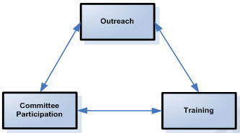
Figure 1: Domain Maintenance Activities
Committee Participation. The success of the NIEM governance structure (NBAC, NTAC and NC&OC) depends on the active engagement of NIEM stakeholders. Domain stakeholders should be actively involved in all three committees. Committee involvement may include participation in monthly conference calls and bi-annual meetings. A committee charter outlines the respective roles and responsibilities for each committee. Stakeholders should contact the NIEM PMO (NIEMPMO@niem.gov) to get involved with the NIEM committees. The benefits of committee participation include:
- Direct communication of user requirements
- Cultivation of relationships with other domains
- Increased awareness of other domain and NIEM activities

Outreach. The principal domain participants come from a COI and regular communication between the members of the COI is imperative to understand the needs of the community and improve the data model. The NIEM PMO recommends following the information contained in Appendix A – Community of Interest, which includes sections that address the following:
- Starting a New Community of Interest
- Community of Interest Checklist
- Advice for Community Coordinators

Training. Another way to get involved with NIEM and maintain the domain is to enhance the capabilities of the COI. Significant informational resources are available online via www.niem.gov; however, the best way to understand the fundamentals of NIEM is to participate in NIEM training. In order to accommodate stakeholders’ differing needs, the NIEM PMO offers two training mediums: instructor-led and computer-based training (CBT). The table below describes the advantages and disadvantages to the NIEM training mediums.

To receive additional information about the training program, please contact the NIEM PMO (NIEMPMO@niem.gov) and/or review section 2.6.4 in the NIEM Concept of Operations.
NIEM Training Medium | Advantage(s) | Disadvantage(s)
Instructor-led training | - Great for groups of stakeholders  - Taught by NIEM experts  - Ability to ask questions  - Opportunity to learn from training peers | - Must be scheduled with the NIEM PMO in advance of the training  - Requires funding or NIEM PMO sponsorship
Computer-based training | - Low cost to enroll and flexibility to complete the courses in the users’ timeframe  - Easy access to training material. No advanced scheduling required | - No current ability to ask questions or learn from peers

Stakeholder Communications
Stakeholder | Responsibilities | Concerns & Key Questions
COI | - Outreach between members  - Communication to related COIs | - What subject or mission area(s) are part of the COI?  - Who is currently involved in the COI?  - Who should be involved in the COI but is not? What are the barriers to getting them involved? How can these barriers be overcome?  - What mechanism captures issues and elevates them within the community? How are these issues resolved?  - What is the communication strategy?
Domain Steward | - Participate in NIEM committee (NBAC, NC&OC, NTAC) activities and meetings | - Who is the appropriate resource from the COI to represent the domain at committee meetings?

Tools & Resources
- NIEM National Training Event (NTE)
- NIEM PMO and NIEM Committees
- NIEM Committee charters
- NIEM training modules

Data Management

Domain Readiness Assessment

Process Purpose
The purpose of this SOP is to apply a standard and rigorous process to the addition of new NIEM domains. This allows the NIEM PMO to provide consistent and repeatable support to new domain candidates and existing NIEM stakeholders seeking to become a new domain. The Domain Readiness Assessment SOP fills a gap in NIEM documentation by providing more scrutiny to domain candidates so new domains do not dilute the value of NIEM.

Process Description
The interactions between NIEM stakeholders (also known as “domain candidates”) and the NIEM PMO begin this process. The NIEM PMO provides the New NIEM Domain Value Proposition template to domain candidates. The template contains three analytical exercises for domain candidates to complete with the support of the NIEM PMO. Upon completing the template, the domain candidate attends the next NBAC meeting to present their completed New NIEM Domain Value Proposition. Afterward, the NBAC may recommend to the Executive Steering Council (ESC) that a new domain be formed or not be formed with a two-thirds vote of present voting NBAC members. The domain candidate must then gain the approval for the creation of a new domain from the NTAC before they can be formally approved by the ESC at the next quarterly ESC meeting. If a domain candidate does not garner enough support from the NBAC, NTAC and ESC, they can begin the process at a later date after they have addressed the identified issues.

Stakeholder Descriptions
Stakeholder | Description
Domain Candidate | Any community of interest that has or has not adopted NIEM, and the substantive information of the community does not already exist within an existing NIEM Domain
NIEM Program Management Office (PMO) | Provides guidance and facilitates initial conversations with domain candidates
NIEM Business Architecture Committee (NBAC) | The NIEM committee whose primary responsibilities are versioning and domain governance
NIEM Technical Architecture Committee (NTAC) | Secondary stakeholder for NIEM domains. Only special circumstances may require NTAC involvement
Executive Steering Council (ESC) | Sets strategic priorities for the NIEM PMO and is the only stakeholder with the formal authority to establish a new domain
Domain Steward(s) | An organizational executive that will sponsor the activity of the domain
Domain Primary Point of Contacts | The individual identified as the domain committee co-chairs (one representing the Federal Government and one representing state and local government
Domain member | A subject matter expert in the topic area of the domain. The domain should adequately represent the community of interest with both Federal government and state & local members
Domain Committee Support staff | The individual responsible for working with the Domain POC to manage the activity of the domain. This role may be filled initial by the NIEM PMO, however on-going support will need to be provided by the organization of the Domain Steward(s)

Standard Activity Flow – Domain Readiness Assessment
Step # | Stakeholder | Action
1 | Domain Candidate | Receives new domain guidance documentation from the NIEM PMO called the “New NIEM Domain Value Proposition.” The domain candidate will complete the document and submit back to the New NIEM Domain Value Proposition to the NIEM PMO. This document provides the following information:  - Readiness of people & resources  - Exchange scenarios  - Sample domain data model
2 | NIEM PMO | The NIEM PMO and domain candidate meet and discuss Step 1. Discussion is focused on whether domain creation is necessary or if joining an existing domain, or building NIEM-conformant IEPDs, or providing definitions and other domain activities are more practical
3 | NBAC | The domain candidate will attend a NBAC meeting to present all or part of its value proposition. With a 2/3 vote among present voting members, the NBAC will, or will not, recommend to the ESC that the domain candidate formally become a domain
4 | NTAC | The domain candidate will attend a NTAC meeting to present all or part of its value proposition. The NTAC will, or will not, recommend to the ESC that the domain candidate formally become a domain
5 | ESC | Upon receiving a recommendation from the NBAC & NTAC that a domain candidate is to become a new domain, the ESC can formally approve creation of the new domain
6 | NIEM PMO, NBAC | If the Domain Candidate is not approved for NIEM addition, a document will be provided that will identify the issues. The Domain Candidate can request NIEM addition at a later date once they have addressed the identified issues.

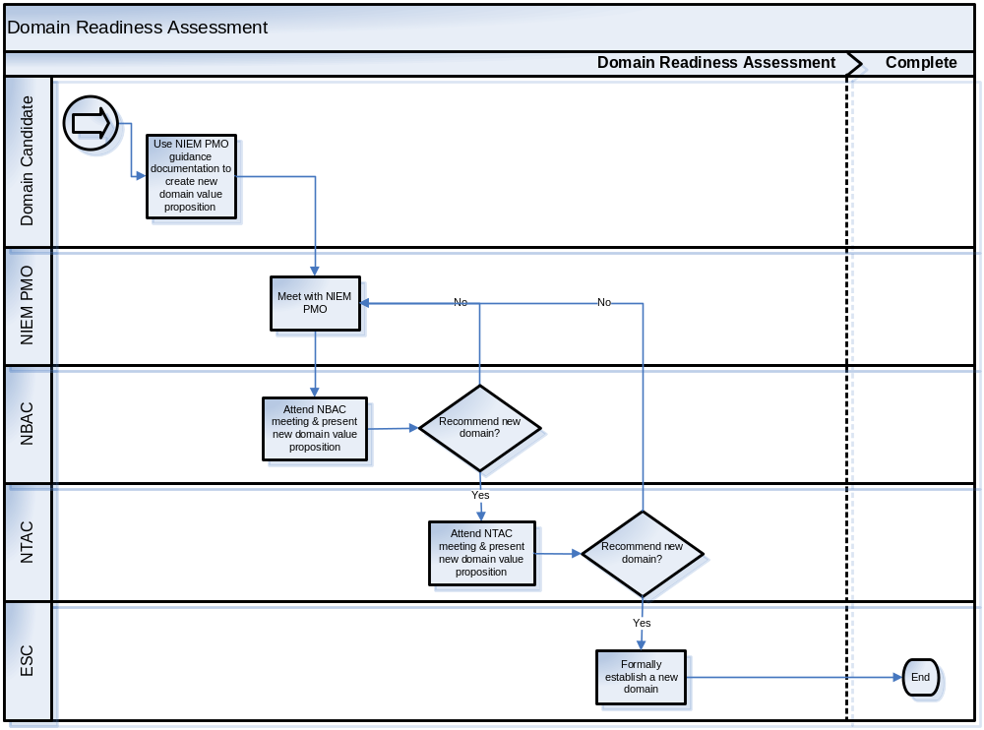

Stakeholder Communications

Stakeholder | Responsibilities | Concerns & Key Questions
Domain Candidate | - Completes New NIEM Domain Value Proposition | - Are there other domains that do what we do? Are there domains that overlap with our domain?  - Who is our community of interest (COI)?  - Who will be our Domain Steward? Do they have the ability to devote a minimum 12 hours per month for 2 consecutive years to help the new domain become established and succeed?  - What is the value-add for the COI in being a NIEM domain? How does this differ from not being a domain and being a NIEM stakeholder that builds NIEM-conformant IEPDs?  - What relevant external data standards and related exchange models exist? And how do these standards integrate with the domain?
NIEM PMO | - Supports domain candidates’ completion of the New NIEM Domain Value Proposition  - Guides NIEM stakeholders through the SOP architecture | - With limited NIEM PMO resources, how confident are we that this domain will become self-sustaining and will benefit the NIEM community? How confident or not confident are we of this when compared to other domain candidates?
NBAC | - Recommends to the ESC the action to be taken on a domain candidate | - How will this domain impact or benefit harmonization & core synchronization?
NTAC | - Provides feedback in the instances when a new domain will dramatically alter the NIEM landscape | - What is the impact on the technical integrity of the NIEM data model and existing IEPDs?
ESC | - Formally establishes a new domain | - How will a new NIEM domain alter the strategic direction?

Tools & Resources
The most important part of this SOP is the domain candidate’s ability to convey the value of a new NIEM domain for their COI and the broader NIEM community. The primary tool that will guide a domain candidate is the New NIEM Domain Value Proposition (see the New NIEM Domain Value Proposition - TBD). This document assists a domain candidate with developing the material necessary for Step 2.

Identify and Define Data

Process Purpose
This process shows the steps a domain should undertake to identify and define data for inclusion as a NIEM domain.

Process Description
The “Identify and Define Data” process is closely intertwined with the mapping data to NIEM. In some cases, identifying and defining data is performed in tandem with mapping to NIEM. Several factors can influence decision making if mapping to NIEM is performed during or after identifying and defining data. These factors include:
- Existence of legacy systems and information exchanges
- Complexity of the data set and, therefore, the domain model
- Knowledge of NIEM data model and existing NIEM data components
A pre-requisite to establishing a NIEM domain is an existing authoritative data source(s) (i.e., associated organizational entities) to govern and maintain the data. This process assumes the domain is following the recommended procedures and has already initiated the “Domain Readiness Assessment” SOP.

Pre-Conditions: | The domain must have at least one authoritative data source (i.e., an associated organizational entity) to govern its data
Post-Conditions: | Domain Content Model

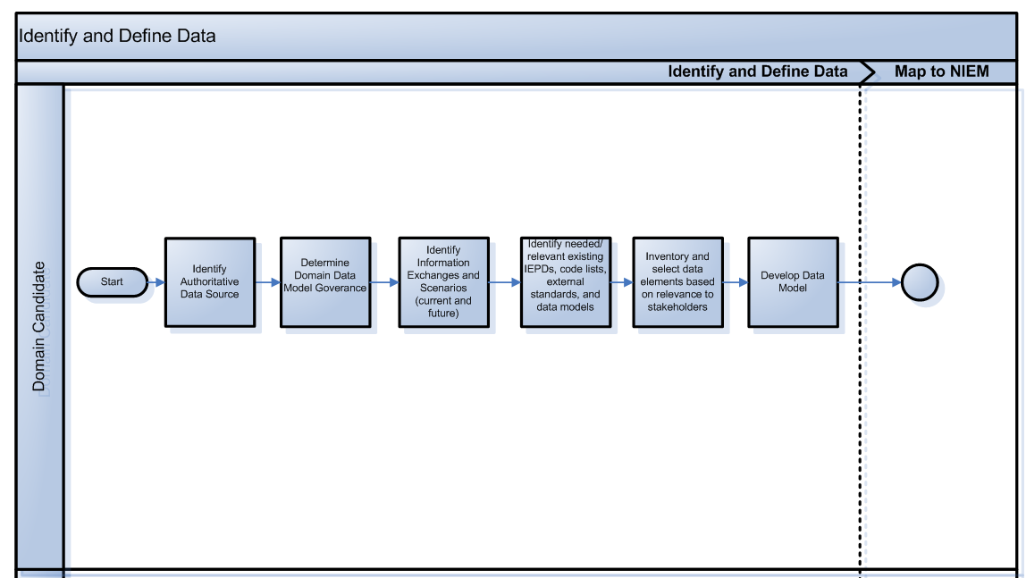

Stakeholder Descriptions
Stakeholder | Description
Domain Candidate | Any organization that has or has not adopted NIEM and would like to develop a domain
NIEM Business Architecture Committee (NBAC) | The NIEM committee whose primary responsibilities are versioning and domain governance

Standard Activity Flow – Identify and Define Data
Step # | Stakeholder | Action
1 | Domain candidate | Identify Authoritative Data Source
2 | Domain candidate | Determine Domain Data Model Governance  Governance for each domain will vary depending on the characteristics and needs of the domain. Below are some factors to consider when determining governance, processes, and procedures for the Domain Data Model:  - How often will the domain data model need to be updated?  - Who will be permitted to update the model?  - How will correct use of the model be enforced?
3 | Domain candidate | Identify Information Exchanges & Scenarios (legacy, current, and future)  In order to identify domain data, domains should first identify the business needs for information exchange(s). If a domain has existing information exchanges, it may be helpful to inventory and evaluate the data in existing exchanges for potential inclusion in the domain model; however keep in mind that the resulting domain model must be driven by COI business needs.
4 | Domain candidate | Identify needed or relevant existing IEPDs, code lists, and external standards
5 | Domain candidate | Inventory and select data elements based on relevance to NIEM stakeholders and the domain COI
6 | Domain candidate | Define Domain Data Model  Different Domain Candidates may not perform the same steps in developing a Domain Model. The process to create the Domain Model varies depending on factors such as: size of domain data model, existence of legacy models and standards, and complexity of complexity. Regardless of the steps taken to develop the domain data model, keep in mind the following characteristics of high-quality data models:  - Ability to represent data being exchanged between organizations and systems  - Understand the information the model is representing along with business rules driving the domain data model  - Ability to extract portions of the domain data model suitable for particular purposes of the broader NIEM community  - Ability to integrate information from different sources to resolve what is already represented versus what needs to be added  - Share the same data between applications and users with different views  Note: In some cases, domains may map to NIEM concurrently with defining the Domain Model. If the Domain Candidate uses this approach, then the NIEM Naming and Design Rules (NDR) will apply and should be used. If not, then the NDR specifications will be applied in the following Map to NIEM activity. Below are common steps that should occur when developing a Domain Model:  - Create or record a data definition for each data element  - Identify entity types and data types  - Identify attributes  - Apply naming conventions (Note: if mapping to NIEM concurrently, then the naming conventions should conform to the specifications in the NDR)  - Identify relationships

Stakeholder Communications
Stakeholder | Responsibilities | Concerns & Key Questions
Domain Candidate | - Completes pre-requisites | - How often will the domain data model need to be updated?  - Who will be permitted to update the model?  - How will correct use of the model be enforced?

Tools & Resources
Tools and resources that will help execute this process include but are not limited to the following:
- Code lists
- External standards
- NIEM NDR

Publish / Release a NIEM Domain or Content

Process Purpose
A significant benefit to using NIEM is its ability and agility to adapt to stakeholder requirements as needed. This SOP describes how new requirements are identified and eventually incorporated back into the model.

Process Description
This process is applicable to both existing domains that have new requirements and stakeholders that have received approval from the ESC to stand up a new domain. It involves several stakeholders to identify and record issues or new requirements in the existing NIEM data model. Depending on the change(s) required, the domain steward, NBAC or a tiger team analyzes and publishes the update(s).

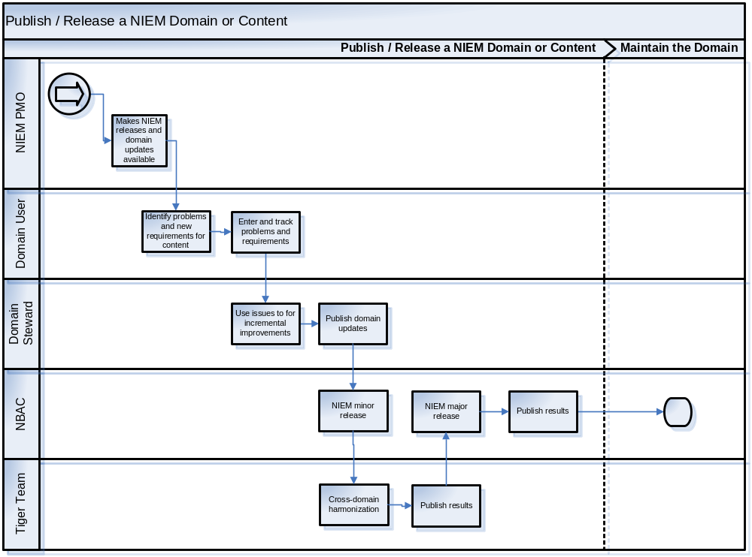

Stakeholder Descriptions
Stakeholder | Description
NIEM PMO | Initiates and manages the publication and release processes
Domain Users | Users include developers of IEPDs, as well as implementers and users of exchanges
Domain Steward | Leader of a specific COI and primary POC for the NBAC
NBAC | The NIEM committee whose primary responsibilities are versioning and domain governance
Tiger Team | A small working group of subject-matter experts (SMEs) formed to solve a specific set of problems. A tiger team exists only for a short time—it is disbanded once it has served its purpose

Standard Activity Flow – Publish/Release a NIEM Domain or Content
Step # | Stakeholder | Action
1 | NIEM PMO | The NIEM PMO makes NIEM releases and domain updates available for use in IEPDs and other purposes
2 | Domain Users | Through use and analysis of NIEM releases and published content, domain users identify problems and new requirements for domain content and Core content
3 | Domain Users | Domain Users enter and track these problems and requirements as issues in the issue tracking area
4 | Domain Steward | NIEM domains use issues as the basis for incremental improvements, extensions, and proposed changes to NIEM releases. Domains may work together via a partition of the collaboration area
5 | Domain Steward | Domains publish their domain updates in three ways: (1) issues are updated and new issues are entered in the issue tracking area; (2) domain schemas are updated in the publication area; and (3) optionally, domains may release coherent schema changes via a NIEM micro release, published in the release area. A minor release is often domain-specific and has a three-digit version ID, such as 3.10.2
6 | NBAC | Periodically, the NBAC reconciles domain updates into a new NIEM minor release. The goals of this release/process are (1) to resolve the conflicts and inconsistencies that are created by new and modified domain content; (2) to produce a coherent set of reference schemas for the domains; and (3) to perform some incremental harmonization on that schema set  This process, called domain reconciliation, is repeated approximately every six months. In this process, the NBAC examines issues, published updates, and releases and reconciles changes to domains into a single coherent domain schema set. The NBAC ensures that all domains reference each other in a consistent way
7 | Tiger Team | At any time, asynchronously with other processes, NBAC may initiate a tiger team to conduct cross-domain harmonization
8 | Tiger Team | The results of tiger teams will be made available in a partition of the publication area. This partition may hold schemas that contain additions to and extensions of the NIEM Core namespace. Each schema is published with a unique namespace, distinct from the NIEM Core namespace. The domains may use these schemas in domain updates, and IEPDs may use these schemas as well. The contents of these partitions of the publication area are considered during the domain reconciliation process (step 6, above), and a supporting schema containing additional Core content may be published with the periodic minor release
9 | NBAC | Approximately every 18–24 months, the results of cross-domain harmonization and domain reconciliation are brought together into a new NIEM major release. This process is called Core synchronization. The NIEM Core namespace is updated with help from issues in the issue tracking area, as well as the published updates from the domains and tiger teams. Domain definitions that were dependent on the previous NIEM Core are harmonized with the updated NIEM Core namespace
10 | NBAC | Core synchronization results in a new NIEM major release, with an updated NIEM Core namespace. A NIEM major release has a two-digit version ID that ends in "0," such as "4.0"

Stakeholder Communications
Stakeholder | Responsibilities | Concerns & Key Questions
NIEM PMO | - Oversees and manages the release processes | - Are the appropriate organizations and committees involved?
Domain Users | - Identify issues  - Communicate new requirements | - What are the gaps with the current model?  - What has changed since the last release?
Domain Steward | - Understand the issues and new requirements  - Involve the appropriate stakeholders | - What are the needs of the COI?  - Does this release meet those needs? Where does it fall short?
NBAC | - Recognize the need for a release  - Distinguish what type of release is needed  - Lead release | - What domains need to be involved? Have they been involved?  - What is the desired outcome?
Tiger Team | - Execute requests from NBAC | - What are the requirements for the NBAC request?

Security and Privacy
One of the key value propositions that the National Information Exchange Model (NIEM) provides is its ability to standardize a framework for information exchanges across domains. In order to provide a reasonable assurance of the confidentiality and integrity of the data being shared, it is imperative for NIEM to have guidelines detailing the best practices that NIEM members should follow to secure data. Similarly, it must be the responsibility of NIEM to provide a reasonable level of security assurance for participants to willingly provide their sensitive or classified information into the domain. This document describes the leading guidance of how classified or sensitive data is secured within an exchange.

“Sensitive” or “classified information” is information not otherwise categorized by statute or regulation that, if disclosed, could have an adverse impact on the welfare or privacy of individuals or the national interest. Examples of sensitive information include personal data such as Social Security numbers, trade secrets, system vulnerability information, etc.

Securing sensitive or classified data within a domain requires a multi-layered approach. Ultimately, the security and privacy of the sensitive and classified data will be a function of the NIEM members’ own information security standards. Thus, it is important that all NIEM members employ a minimum standard of information security protections to participate in the IEPD and information exchange process.

Industry Standards
It is the prerogative of each NIEM member organization to employ information security standards that are of adequate protection commensurate with the value of information stored. The guidelines of this document exist to demonstrate a portion of those standards, as well as to direct NIEM members as to where information about data security can be found. At minimum, this approach consists of procedures for industry leading standards of security in the information, organizational and physical level.

Information Security
A sufficient identity and access management program will also allow only authorized users with the appropriate credentials and required training to analyze information on the domain. Credentialed, role-based access management protections are crucial for information security and privacy considerations. Access review, along with an audit log and audit trail maintained by NIEM, will identify and limit the authorized user making a data request through a domain, the data of the inquiry, and the information that the authorized user has accessed. Additionally, a data retention program will allow information to be retained in a way so that it cannot be modified, accessed, destroyed or purged except by authorized domain users. Similarly, all sensitive and classified personally identifiable information (PII) traveling through the NIEM domain shall include, if possible, the name of the originating collector, the information system from which the information is provided, the date of collection, and the title and contact information for the data steward in the originating agency. All personally identifiable information with access restrictions will be marked when it is shared to reflect any limitations on access and sensitivity of disclosure.

Organizational Security
An organization’s policy for protection of sensitive and classified data can only be as strong as the personnel’s prerogative for implementation. Therefore, it is important that all personnel who utilize the NIEM domain exchange be aware of the necessity for information security and privacy. This includes an awareness of the consequences of non-compliance. Policies such as password guidelines, asset inventories, desk audits and regulation around use of real data in production can be helpful in implementing security and privacy by design in a NIEM member organization. Finally, training to employees and contractors on proper usage of the NIEM domains and information sharing is of paramount importance for any NIEM member organization. Security awareness training for all personnel in support of NIEM Exchanges should be mandatory, with additional targeted security training for personnel in special functions. It is important to have different levels of training based on users’ familiarity with the concepts behind securing sensitive and classified data in the information space.
Physical Security
In order to best protect the security and privacy of sensitive or classified data, NIEM must have basic standards for physical security. This includes standards as to access to organization buildings, controls for detecting unauthorized access, and visitor procedures. Additionally, NIEM member organizations should have policies on secure workspaces including securing sensitive data in locked spaces at all times, encrypting flash drives, and preventing the downloading of sensitive information onto unauthorized media.
The guidelines established in this document contain these basic industry standards for the purpose of giving a reasonable level of assurance to NIEM members of the security standards of the exchanges and other organizations.

Incident Reporting
Before entering an information sharing partnership such as NIEM, members should have a procedure for how they will handle a security incident. Even with leading edge industry standards for protecting the privacy and integrity of shared data, security incidents can occur. Member organizations will find that during these incidents, it is very helpful to have an established repeatable protocol for action. One major part of this protocol is establishing, in advance, a categorization for security incident types. Without categorization, each incident must be handled in the same manner. That is neither practical nor efficient. Instead, having a security classification guide permits the organization to make quick data-driven decisions on action steps.

This figure shows a methodical way to review and respond to a security incident.

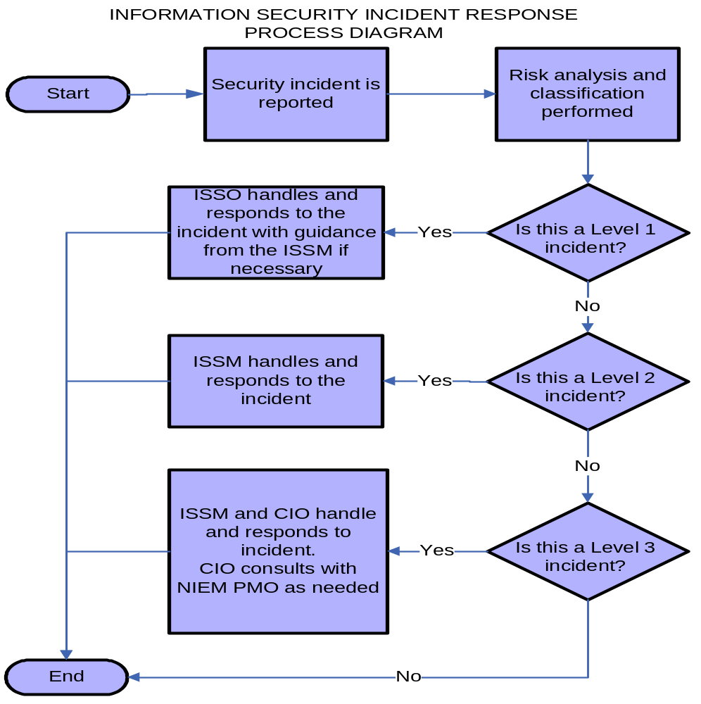

Stakeholder Responsibilities
All NIEM stakeholders have a shared responsibility for assuring privacy information security. The table below displays some of the responsibilities of those within the NIEM community.
Stakeholder | Responsibilities
NIEM Community | Understand the procedures that NIEM takes to protect information in the domains.
NIEM PMO | Provide guidance on the protection of sensitive information in NIEM domains
NIEM NTAC | Review system architecture to ensure systems are adequately protecting data confidentiality and integrity.
NIEM ISSM | Provide assurance that the NIEM domain exchanges and NIEM members’ information systems are at least as secure as required by NIST guidelines
Domain User | Document a request for the sharing of information through a NIEM domain that includes details on the rationale for the request and specific purpose as required by law.
Data Steward | Limit the collection of sensitive data and consider implications of sharing information in NIEM domains.
Agency ISSO | Periodically review audit log to ensure that data is shared appropriately through the NIEM exchange
Functional Manager | Approve employee and contractor access to information systems.  Periodically review employee and contractor access to sensitive information systems.

Tools & Resources
There exists a multitude of tools and resources available as members strive to protect sensitive and classified data in the domains. Many of these tools are considered industry standard and are being utilized by DHS and NIEM.
- Logging mechanisms such as Windows Event Log, firewall logs and Microsoft System Center Operations Manager, and standard Unix tools can audit system events for intrusions and specific uncharacteristic use
- Industry leading Identity and Access Management protocols such as two layer authentication, Entrust tokens and Digital Certificates on USB tokens can provide additional security
- Encryption Standards can utilize the VPN, IPSEC, Remote Desktop and Citrix protocols

References
- NIEM National Training Event (NTE)
- NIEM PMO and NIEM Committees
- NIEM training modules
- ISO 17799
- DHS 4300A
- Federal Information Security Management Act (FISMA) of 2002, November 25, 2002
- Privacy Act of 1974, As Amended. 5 United States Code (U.S.C.) 552a, Public Law 93-579, Washington, D.C., July 14, 1987
- Public Law 107-296, Homeland Security Act of 2002
- Office of Management and Budget (OMB) Circular A-130, Management of Federal Information Resources
- National Institute of Standards and Technology (NIST) Special Publications (e.g., 800-16, 800-34, 800-37, 800-50, 800-53) and Federal Information Processing Standards (FIPS) (e.g., FIPS 199, 200)

Interoperability

Cross-domain Harmonization
TBD

Core Synchronization
TBD

Domain Reconciliation
TBD

Appendix A – Community of Interest

Starting a New Community
Anyone can start a community, but to flourish it needs the right environment. Following the key steps below will help you take your community from an idea to a hive of collaboration and innovation.
Step 1: Getting Started
- What is the business need? Test out ideas with people in your immediate network – they could be future members
- Start to identify other people that may be interested in joining. Who might the target audience be? Consider keeping the community small until it finds its focus and grows slowly over time
- Who are the leaders in this area? Are there any pre-existing networks? What could a new community achieve that the existing group is not already doing?
Step 2: Plan and Develop
The first action should be to establish a core community team – people who are knowledgeable about the topic/issue, and who have a vested interest in setting up the community. Set up a meeting with them to:
- Develop a vision for the community – decide on goals and objective(s), it can be useful to have a mission statement
- Consider how you will promote the community to build interest, and how you will enable people to join
- Allocate roles and responsibilities and ensure that these are made clear
- Do you need a budget for events? Where will this come from?
Use the Community Checklist (below) to help with your planning.
Step 3: Launch and operate
- Consider whether you want a high visibility launch (e.g. a face-to-face meeting or conference call) or a low visibility launch with a simple email to potential members
- At the launch, discuss mission, objectives and basic structure of how the community will work – these should reflect the needs of members
- Find out how often members want to meet – face-to-face meetings can be key to building relationships and trust, so that members feel comfortable sharing their knowledge
- Plan regular activities to keep the energy going and create a ‘rhythm’. Combine familiarity with excitement – consider inviting outside speakers occasionally
- Agree on which tools/methods you will use to communicate and share knowledge
Step 4: Monitor and Measure
Communities evolve and mature over time. Objectives may alter, members may change. It’s quite common for subgroups to form within a community which focus on specific topics or ideas. However if the business need is still valid and the community are still seeing benefits, then the community should continue
- The core team should evaluate community activities, what’s going well, what’s not. Consider surveying members to check that community activities are reflecting their needs
- A successful community has a steady ‘rhythm.’ Too fast and the community can feel breathless, with members feeling overwhelmed. Too slow and it can feel sluggish, people become disengaged. Check with members what feels right.
There will be times however when the community reaches a natural end. Members may wish to start or join another community in response to another business need.

Community Core Team – Roles and Responsibilities
The core team is the beating heart of the community. However, there are a couple of key roles which need to be established and will help your community flourish. For smaller communities, the leader/coordinator roles can be undertaken by the same person, but these responsibilities do take time and their importance should not be underestimated (See Advice for Community Coordinators below for more information).
Community Sponsor:
- A senior sponsor from the business will help to provide credibility and support community activities
- Monitors outcomes to ensure business critical focus of the community
- Works with the community leader to track progress
Community Leader:
- Is a member of the core team
- High profile and well-respected
- Must have knowledge of the subject, plus enthusiasm and belief in what the community is aiming to achieve
- Helps to establish and articulate community purpose and objectives
- Gives the community direction and keeps on track
- May chair the community meetings
- Works with the coordinator to organize community activities and drive membership
- Acts as liaison with other communities and serves as a subject matter expert
Community Coordinator:
- Is a member of the core team
- Coordinates communications
- Supports member requests
- Provides guidance and organizational support including admin tasks, arranging events and meetings
- Supports overall goals and activities of the community and its’ leaders

Community Checklist
This checklist can be used when you are starting a new community, but will also be a useful checkpoint for existing communities looking to improve the value of their community activity.

Community name | - Name should be indicative of community topic and any other essential distinguishing features
Topic | - What is the business need/issue you are trying to solve?  - What subjects will be discussed?  - What are the current levels of activity around this topic?
Community Sponsors | - Select recognizable leaders in the related topic area who will champion your community and help you to drive participation via events, conference calls, and dedicated community correspondence
Objectives, Mission, Vision Statement | - Why should your community exist?  - What knowledge do you think potential members will find useful to share?
Target Audience | - List any existing teams that could form the core team for your new community. For example, a team whose mission aligns with the topic for your new community. List any existing distribution lists of people interested in the topic. Is there an inactive community that could be resurrected or migrated to form your new community?  - Consider how you will promote the community to build interest, and how you will enable people to join (e.g. email community coordinator, completing an online form)
Core Members | - People who are knowledgeable in the community topic and who will help answer questions, assist the Leader/Coodinator to keep the community active, may present on calls and at meetings and regularly share in discussions
Community Leader | - For smaller communities this role could be merged with the Community Coordinator. As a member of the core team, this person will drive community activities, keep the community on track, report to Sponsor
Community Coordinator | - For smaller communities, this role could be merged with the Community Leader. As a member of the core team, this person will organize community activities, perform admin tasks, coordinate communications, support member requests
Launch | - Promote new community through distribution lists, community site and other appropriate channels  - Schedule and host a launch event (face-to-face where possible) to introduce community concept, sponsors/leaders, and next steps
Tools and Resources | - Consider how members will communicate with each other, ask questions, and share knowledge outside of community meetings (distribution list, eRoom, Wiki, Intranet site, discussion forum)
Measures of Success | - How will you know that you are meeting the community objectives?  - Measures will be specific to each individual community but could include: size of membership, number of events, attendance at events/materials/documents shared and developed by the community

Advice for community coordinators
Communities can be informal and self-managed, but are unlikely to reach their full potential without some degree of structure. A key role in helping to provide this structure is the community coordinator.

The purpose of a coordinator is to support, coordinate and promote community activities which connect members so that they can share knowledge. Time spent on this role will depend on the size of the community, and it may be easier to have more than one coordinator for larger communities.

What does the coordinator do?
- Keeps the three community elements in balance: Topic – what the community is talking about; Practice – how the community operates; Relationships – fostering relationships between community members
- Helps to connect members so that they can share knowledge effectively
- Identifies important topics
- Plans and facilitates community events
- Helps build the practice – sets the tone of community meetings, style of communications, use of tools
- Assesses health of the community and works to improve if necessary
What makes a good community coordinator?
- Well-respected within the community
- Knowledgeable about the topic but doesn’t have to be an expert
- Passionate about the community topic and enthusiastic about building the community
- A good networker with strong communication skills
Launching the community
Probably the first action for the coordinator will be planning the community launch.
- What kind of event will be meaningful to members? The type of launch you have will depend on where your potential members are located and what kind of budget you have
- Consider whether you want to have a high visibility launch – a face-to-face meeting, conference call etc. Or low visibility with a simple email to potential members and build slowly from there
- Promote the launch through distribution lists, community site and other appropriate channels
- Use the launch event to seek agreement from members on the topic to be covered by the community, the purpose and objectives, including the value of sharing knowledge on this topic. Other discussions points will be how often members want to meet, tools you will use to communicate and share knowledge
Keeping the energy going
The launch usually generates lots of energy and excitement, with promises for members to stay in touch and share knowledge. But it’s not unusual for people to get back to the work place and lose enthusiasm. The biggest challenge for the coordinators is to keep the energy going after the event and help the community become established.

The easiest way to do this is to set up a program of activity to develop a rhythm. The community coordinator can:
- Organize formal activities, for example, schedule phone/ online/ face-to-face meetings to discuss a hot topic. Build in some time for people to chat informally and get to know each other at these activities
- Introduce the occasional get together for variety – socializing helps build relationships and encourages connections between members outside of the formal events
- Spot hot topics that the community are discussing or can discuss. Use these hot topics in face-to-face or virtual discussions to keep them fresh and vibrant
- Listen out for particular everyday work problems that members are facing. Look for opportunities to link people with problems with people with solutions
- Spot experts – encourage them to hold master classes so the whole community get up to speed on a particular topic
- Encourage participation by sending personalized invitations to face-to-face/virtual meetings
- Advertise community activities widely to recruit new members
- Consider the use of a community online space to share materials and communicate. The chosen tool must be accessible by all community members
Being a coordinator – reward and recognition
The coordinator role can be hugely rewarding.
- Provides a forum for peer group support
- Supports you ongoing professional development
- However, the role requires time, energy, and commitment. Community coordinators should ensure their manager understands the responsibilities of the role and recognizes these in annual objectives and appraisal
Community members
Communities usually consist of three types of member, each with different levels of participation. The coordinator should try to ensure that all members feel they are part of the community, but bear in mind that your members probably won’t be involved in every activity.

Use your core team to help you engage members at different levels and design activities which suit them.
- Core members – closely involved in the organization of the community, suggesting topics for community meetings. Usually forms about 10% of the size of the membership
- Active members – attend meetings regularly, participate in discussions
- Extended members – may form a large proportion of the community, participation will be limited. They keep to the sidelines, watching the interaction between core and active members. This may be because they do not feel able to contribute, or have time constraints

Appendix B – Considerations for NCCT issues and associated data modeling
Issue encountered before?
Solution exists? Precedent or history for solution exists?
Similar issue/solution can be adapted?

Common problem with a common (or easy) solution?
Lexical issue: misspelling, typo, non-UTF char, etc.?
Bad definition?
Add code(s)?
Add a property to a type? (And create type? Or reuse existing type?)
Others?

General value:
How significant is this data requirement to Core?
Issue scope and impact? Domains impacted?
Domain-specific requirement?
How much is it used? Will it be used?
Similar/identical component exists to use instead?
Worth time and resources to resolve or fix?
Worth commissioning a tiger team?
Does this issue have architectural consequences? (NTAC issue)
Does resolving this issue require architectural changes? (NTAC issue)

Issue Classifications:
Name change (Check similar component names that could conflict.)
Definition change
Type change (Check properties it contains and all properties of this type.)
Property change (Check all locations where reused.)
New property (Will be used in what subject types? Its object type?)
New type (Derived from what base-type? Not derived (free-standing)? Rationale?)
Delete property (Check all locations where used. Object type still required?)
Delete type (Check all properties of this type. Are properties contained still needed?)
Deconflict or disambiguate duplicative semantics
Other issue classes?

For each NIEM data component (new/modified/deleted):

Component, use, representation:
1. What is the component?
a. Characteristic or sub-part? Yes, continue to #2. (property)
b. Type Yes, continue to #2. (type)
c. Relationship (association)? Yes, skip to #6.
d. Role? Yes, skip to #7.
e. Augmentation? Yes, pass issue to appropriate domain to resolve.
f. Has architectural impact? Yes, pass issue to NTAC.
2. Core component or domain component?
a. Universal or common enough to be part of NIEM Core? (depth)
Or better used as a domain-specific extension to NIEM?
b. What kinds of NIEM data exchanges would require/use it? (scope)
c. Reusable in many kinds of exchanges? (scope)
d. Requirement exists in multiple sources or models? Which ones? (source)
e. How used? (Primary context? Multiple contexts?)
3. If too specific, then …
a. Only reusable in special cases?
b. Can be generalized for use in Core?
c. Better put into a NIEM domain namespace? Which?
d. Better used as IEPD extension? Or in an EIEM?
4. Component overlaps an existing component? Is not distinct?
a. Join with another component? (close relationship)
b. Split into multiple components? (too broad)
c. Select one representation and remove others?
5. Skip to #8.

Special representations:
6. Relationship type (associations to other objects)
a. What objects does this component commonly associate with?
b. Associates with multiple objects simultaneously?
c. Properties of this association?
d. Skip to #8.
7. Role
a. What is this object a role of?
b. Additional properties does this object adds to the properties in the object it is a role of?
c. Skip to #8.

Name, definition, structure:
8. Name meaningful and distinct in NIEM Core? (avoid ambiguity)
a. Appropriately named?
b. Terms of name are meaningful?
c. Meaningful definitions for each term? Proper word sense identified?
d. Terms: real-world object / property (the semantic focus) / representation.
e. Optional qualifier terms to ensure clarity or distinction?
9. Definition meaningful and distinct in NIEM Core? (avoid ambiguity)
a. Defined distinctly from other existing NIEM data components?
b. Keywords? Examples of common data instances? Explanation of usage?
c. Definition or other fields contain references to other existing components?
d. See note below re component name and definition.
10. Modeled correctly? structurally correct? Reasonable correspondence to real-world?
a. Type derived from appropriate base-type (multiple inheritance an issue?)
b. Type contains appropriate characteristic or sub-part properties?
c. Can this component be a reference (id/idref) to a large content-bearing object?

Regarding NIEM data component names and definitions:
Sometimes it is difficult to name and define a component. You want a meaningful name that is easy to understand quickly, and so that the name tend to “define” the semantics of the component. Strictly speaking, a dictionary definition does not reuse the defined word (or even a root of the word) in the definition of the word. We would also like such definitions for NIEM. However, a good component name and definition that does not reuse a term in the name are often hard to conceive, because these can be conflicting requirements. If you use good descriptive terms for the name, then you must identify one or more good synonyms for the definition. But if you find a good synonym to use in the definition, you might ask yourself why you didn’t use that synonym in the name instead. As a result of this conundrum, NIEM does not require strict dictionary definitions. Reuse of component-name terms in the definition is acceptable if the resulting meaning is relatively common, easy to understand, and is not ambiguous.

Appendix C – Domain Charter Template

Purpose
Guidance: Describe the business purpose of the domain being defined. Provide statements of the business needs that must be met in order to accomplish the business objectives of the domain. Define why this governance document is needed.

Background
Guidance: Provide background information on the domain and governing organization, including an initial assessment of the domain, external assessment of the organization and analysis of the domain-related issues. Some additional factors to consider include:
- Domain Stewarding Organization Profile-Provide information about the organization that is stewarding the domain, including: organization overview, management, technical personnel, and other relevant individuals, locations, or items that define the organization
- Internal Assessment- Document the organization’s current situation that led to stewarding the domain. This information can include any models or analysis about functions, processes, performance, information, technology, or organization. This information should also include a preliminary assessment of any capability transfer issues, preliminary training needs, and legal ramifications
- External Assessment- Provide information on the domain’s customers or markets. This external assessment can include information about the functional, technical, operational, informational, or managerial aspects related to the current state
- Strategic Analysis- Enter information from the assessment that leads to any objectives, goals, or risks associated with the domain

Domain Sponsors
Guidance: A brief written statement should identify the project authorization and Executive Sponsors/owners

Goals
Guidance: Think about the results intended for the domain. Having clear, agreed-upon, goals that are seldom changed is vital to domain success. Start with broader goals, then identify any more specific or sub goals goals. All goals should be:
- Specific
- Measurable
- Achievable
- Relevant to the domain strategy
- Time-lined

Scope
Guidance: Consider the following dimensions of scope:

- Organizational – a high-level scope statement about the organizational agencies, divisions, and business units included in and excluded from the domain

- Functional - a high-level scope statement about the functions or applications included in and excluded from the domain

- Process - a high-level scope statement about the business processes included in and excluded from the domain

- Technical- a high-level scope statement about the technical infrastructure and systems included in and excluded from the domain

- Often it is best to also include what is not in the scope of the domain

Domain Risk Management
Guidance: Identify the scope of risk management, primary risk concerns and associated effects, organization’s sensitivity to risk, and basic approach toward risk management. Define the strategic risks, including external forces. These may include business risks, economic risks, technology changes, and major organizational changes. Risk responses, including mitigations, risk avoidance, and risk tolerances should be described in this section of the charter.

Membership and Structure

Working Groups and Committees
Guidance: Identify any groups, committees, sub-committees, or panels that will provide the governance needed for the domain success. Some potential groups include: Executive Steering Council, Data Governance Working Group, Subject Matter Expert (SME) Integrated Project Team.

Roles and Responsibilities
Guidance: List the roles of stakeholders/members, and how they will contribute to the project. Think about the key functions of the group and identify at a high level how they will be performed in order to accomplish the domain’s goals. Be sure to consider decision making processes, including what should happen if there is disagreement among stakeholders.

Meetings and Communication
Guidance: Consider the frequency of committee meetings, and if meetings should occur in person, over the phone, or via a web-conference. Also, committees and working groups will likely work closely with other bodies within the domain, and in the NIEM governance structure (example of NIEM governance structure committees include the NIEM Business Architecture Committee (NBAC) and NIEM Technical Architecture Committee (NTAC)). There should also be a significant amount of cross-committee communication, and it may be helpful to document the minimum cross-committee communication that is required.

Compliance
Guidance: Some domains may find it useful to include a high-level statement about compliance of participating agencies with the domain processes and standards. The processes and governance structures will likely provide, and require, participation and information availability among stakeholders to reach the goals of the domain.

Success Criteria/Performance Measurement
Guidance: Determine the success criteria of a project. Generally, aggressive but doable success criteria will help motivate team members.
To evaluate the performance of a domain, it is useful to track relevant metrics. Potential metrics could include, but are not limited to, the following:
- Maintaining a deliverable schedule
- Domain data elements reused
- Number of NIEM-conformant IEPDs developed
- IEPDs reused
- IEPDs implemented

Sections 2.2.1-2.2.3 highlight the information captured in Appendix A – Community of Interest. Please reference Appendix A in addition to these sections.
There are technical processes required to maintain the domain. These processes are covered in detail in Domain Reconciliation, Cross-domain Harmonization, and Core Synchronization.
http://www.niem.gov/topicIndex.php?topic=file-conops
This SOP content comes from Section 3.4 of the NIEM High-Level Version Architecture.
With the exception of certain types of information protected by statute (e.g. Sensitive Security Information, Critical Infrastructure Information), there are no specific Federal criteria and no standard terminology for designating types of sensitive information. Such designations are left to the discretion of each individual Federal agency. “For Official Use Only” (FOUO) is the term used within DHS to identify unclassified information of a sensitive nature that is not otherwise categorized by statute or regulation.
More information on the basics of information security standards can be found in DHS 4300A

